Result on Ros2 Aruco detector

Actual distance | 0.200m | 0.300m | 0.400m | 0.500m | 0.600m
Marker size 0.05x0.05m | 0.202m | 0.303m | 0.416m | 0.532m | 0.646m
Marker size 0.1x0.1m | 0.190m | 0.310m | 0.415m | 0.522m | 0.640m
Marker size 0.15x0.15m | 0.207m | 0.308m | 0.420m | 0.530m | 0.644m

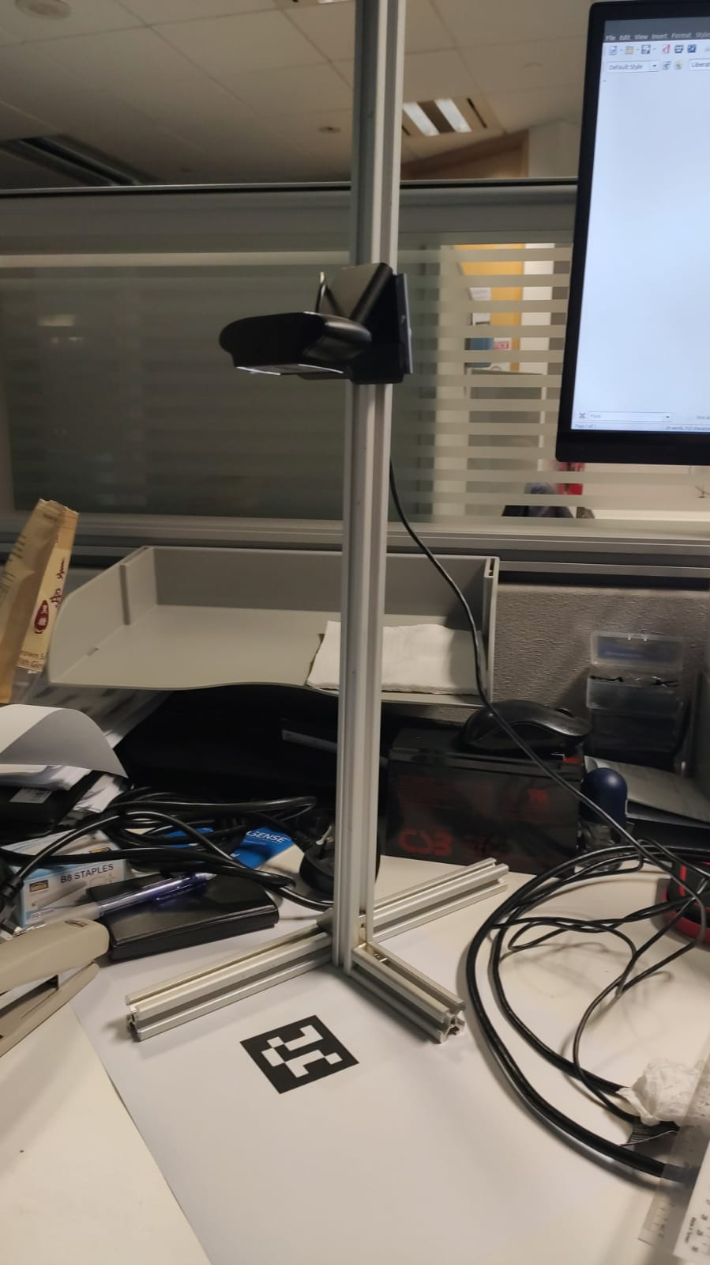
The figure above showing the setup method to record the experiment result. The camera is flexible to move up and down within 20cm to 60cm movable range. The table have record the reading of distance between marker and camera that measured from ros2 Aruco detector. The variable was used different size of marker and measured on different distance between Aruco marker and camera.

From experiment shows, the further the distance between Aruco marker and camera, the larger measuring error. This error might also cause by accuracy of camera calibration parameter. The marker size did not show significant error different in distance vary in marker size.

